Q1.
Figure 1 represents a transverse wave.
Figure 1
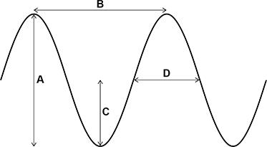
(a) Which arrow represents the amplitude of the wave?
Tick (✓) one box.

A |  | B |  | C |  | D
(1)
(b) Which arrow represents the wavelength of the wave?
Tick (✓) one box.

A |  | B |  | C |  | D
(1)
(c) A wave has a frequency of 5000 Hz.
Calculate the period of the wave.
Use the equation:

___________________________________________________________________
___________________________________________________________________
___________________________________________________________________
Period = ____________________ s
(2)
(d) Give one example of a transverse wave that can travel through a vacuum.
___________________________________________________________________
(1)
(e) Figure 2 represents a longitudinal wave.
Figure 2

Which point is at the centre of a rarefaction?
Tick (✓) one box.

E |  | F |  | G
(1)
(f) A sound wave has a frequency of 750 Hz.
speed of sound in air = 330 m/s
Calculate the wavelength of the sound wave.
Use the equation:
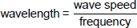
___________________________________________________________________
___________________________________________________________________
___________________________________________________________________
Wavelength = ____________________ m
(2)
(g) Describe a method that could be used to determine the speed of sound in air.
___________________________________________________________________
___________________________________________________________________
___________________________________________________________________
___________________________________________________________________
___________________________________________________________________
___________________________________________________________________
___________________________________________________________________
___________________________________________________________________
___________________________________________________________________
___________________________________________________________________
___________________________________________________________________
___________________________________________________________________
(4)
(h) When a sound wave moves from air into water, the speed of the wave increases.
The frequency of the sound wave does not change.
Complete the sentence.
Choose the answer from the box.

decreases | stays the same | increases

When a sound wave moves from air into water its wavelength
______________________________ .
(1)
(Total 13 marks)
Q2.
Waves may be longitudinal or transverse.
(a) Describe the differences between longitudinal waves and transverse waves.
___________________________________________________________________
___________________________________________________________________
___________________________________________________________________
___________________________________________________________________
___________________________________________________________________
___________________________________________________________________
___________________________________________________________________
___________________________________________________________________
(3)
(b) Radio waves are electromagnetic waves.
Describe how radio waves are different from sound waves.
___________________________________________________________________
___________________________________________________________________
___________________________________________________________________
___________________________________________________________________
___________________________________________________________________
___________________________________________________________________
___________________________________________________________________
___________________________________________________________________
(4)
(Total 7 marks)
Q3.
Figure 1 shows a water wave.
Figure 1

(a) What type of wave is a water wave?
Tick (✓) one box.

Electromagnetic
Longitudinal
Transverse
(1)
(b) Which statement describes the movement of the water at point X?
Tick (✓) one box.

The water at point X does not move.
The water at point X moves to the left and right.
The water at point X moves up and down.
(1)
(c) The wave has a frequency of 2.0 hertz.
The wavelength is 0.032 metres.
Calculate the wave speed.
Use the equation:
wave speed = frequency × wavelength
Choose the unit from the box.

m²/s | m/s | s²
___________________________________________________________________
___________________________________________________________________
___________________________________________________________________
Wave speed = _______________ Unit __________
(3)
(d) What is transferred by all waves?
Tick (✓) one box.

Energy
Information
Water
(1)
Figure 2 shows four water waves.
The waves are all drawn to the same scale.
The waves all travel at the same speed.
Figure 2
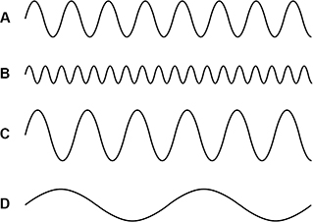
(e) Which wave has the longest wavelength?
Tick (✓) one box.

A |  | B |  | C |  | D
(1)
(f) Which wave has the highest frequency?
Tick (✓) one box.

A |  | B |  | C |  | D
(1)
(Total 8 marks)
Q4.
(a) Complete the following sentence:
Sound is produced when an object ________________________
(1)
(b) Choose words from the list to complete the following sentences:
higher louder lower quieter
(i) If the frequency is increased, the pitch of the sound becomes
____________
(ii) If its amplitude is increased, the sound becomes
______________________
(2)
(c) The diagram shows a pre-natal scan.
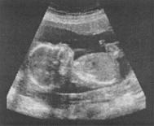
(i) What type of waves are used for pre-natal scanning?
______________________________________________________________
(1)
(ii) Explain why we cannot hear these waves.
______________________________________________________________
(2)
(Total 6 marks)
Q5.
Electromagnetic waves are transverse.
The figure below represents a transverse wave.
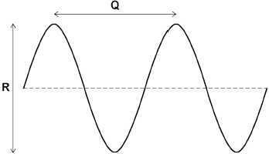
(a) Which of the following gives the wavelength of the transverse wave?
Tick (✓) one box.

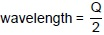
wavelength = Q
wavelength = 2 Q
(1)
(b) Which of the following gives the amplitude of the transverse wave?
Tick (✓) one box.

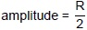
amplitude = R
amplitude = 2 R
(1)
(c) Microwaves are electromagnetic waves used for mobile phone communications.
Which other type of electromagnetic wave is also used for communications?
Tick (✓) one box.

Radio waves
Ultraviolet
X-rays
(1)
(d) Microwaves from a mobile phone take 0.000 009 s to reach a mobile phone mast.
speed of microwaves = 300 000 000 m/s
Calculate the distance between the mobile phone and the mobile phone mast.
Use the equation:
distance = speed × time
___________________________________________________________________
___________________________________________________________________
___________________________________________________________________
Distance = ____________________ m
(2)
(e) Mobile phone communications is only one of the uses for microwaves.
Give one other use of microwaves.
___________________________________________________________________
___________________________________________________________________
(1)
(Total 6 marks)
Q6.
(a) Diagram 1 shows two waves.
Diagram 1
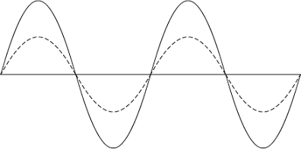
(i) Name one wave quantity that is the same for the two waves.
______________________________________________________________
(1)
(ii) Name one wave quantity that is different for the two waves.
______________________________________________________________
(1)
(iii) The waves in Diagram 1 are transverse.
Which one of the following types of wave is not a transverse wave?
Draw a ring around the correct answer.

gamma rays | sound | visible light
(1)
(b) Diagram 2 shows water waves in a ripple tank moving towards and passing through a gap in a barrier.
Diagram 2
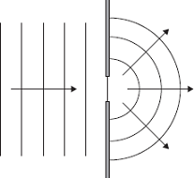
Every second, 8 waves pass through the gap in the barrier. The waves have a wavelength of 0.015 metres.
Calculate the speed of the water waves and give the unit.
___________________________________________________________________
___________________________________________________________________
___________________________________________________________________
Speed = ___________________________________
(3)
(Total 6 marks)
Q7.
(a) Ultrasound is sound above the maximum frequency that humans can hear.
Tick (✔) one box.

20 Hz | 
2000 Hz
20 000 Hz
(1)
(b) The image shows a submerged submarine.
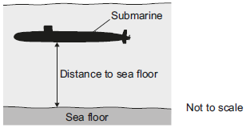
The submarine sends a pulse of ultrasound to the sea floor.
The pulse takes 0.25 seconds to travel from the submarine to the sea floor.
The speed of sound in water is 1600 m/s.
Calculate the distance from the submarine to the sea floor.
___________________________________________________________________
___________________________________________________________________
___________________________________________________________________
___________________________________________________________________
Distance = ___________ m
(2)
(c) The ultrasound is reflected from the sea floor back to the submarine.
Use the correct answer from the box to complete the sentence.

half | the same as | twice
The total distance the ultrasound pulse travelled is __________ the distance to the sea floor.
(1)
(d) The submarine moves through the sea and every few seconds sends a pulse of ultrasound to check the distance to the sea floor.
The table shows the time taken for five ultrasound pulses to travel from the submarine to the sea floor and back to the submarine.

Pulse number | Time for pulse to return in seconds
1 | 0.50
2 | 0.45
3 | 0.38
4 | 0.40
5 | 0.48
Describe how the distance from the submarine to the sea floor changed over these five pulses.
___________________________________________________________________
___________________________________________________________________
___________________________________________________________________
___________________________________________________________________
(2)
(Total 6 marks)
Q8.
Sound travels as longitudinal waves.
(a) Complete the sentences.
Choose the answers from the box.

amplitude | frequency | speed | wavelength
The distance between the centre of one compression of a sound wave and the centre
of the next compression is called the _____________________________.
The number of waves passing a point each second is called the
_____________________________.
(2)
(b) Complete the sentence.
Choose the answer from the box.

opposite | perpendicular | parallel
In a longitudinal wave, the oscillations are _____________________________
to the direction of energy transfer.
(1)
(c) A sound wave has a frequency of 8.0 kHz.
Which of the following is the same as 8.0 kHz?
Tick (✓) one box.

0.0080 Hz
8.0 Hz
8000 Hz
800 000 Hz
(1)
(d) Calculate the period of a sound wave with a frequency of 8.0 kHz.
Use the Physics Equations Sheet.
___________________________________________________________________
___________________________________________________________________
Period = _______________ s
(2)
(e) Calculate the wavelength of a sound wave with a frequency of 6600 Hz.
speed of sound = 330 m/s
Use the equation:
wavelength = 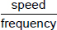
Choose the unit from the box.

kg | m | N
___________________________________________________________________
___________________________________________________________________
___________________________________________________________________
___________________________________________________________________
Wavelength = __________ Unit _______
(3)
The figure below shows the arrangement of two loudspeakers at a concert venue.
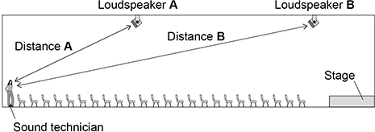
The loudspeakers in above diagram are tested by playing the same song through both loudspeakers.
A sound technician listens to the song.
Use the Physics Equations Sheet to answer parts (f) and (g).
(f) Write down the equation which links distance (s), speed (v) and time (t).
___________________________________________________________________
(1)
(g) Distance A on above diagram is 13.2 m.
speed of sound = 330 m/s
Calculate the time taken for the sound to travel from loudspeaker A to the technician.
___________________________________________________________________
___________________________________________________________________
___________________________________________________________________
___________________________________________________________________
___________________________________________________________________
Time taken = _______________ s
(3)
(h) The sound from each loudspeaker travels at the same speed.
For the sound technician to hear the song clearly, the sound from loudspeaker B should be emitted slightly before the sound from loudspeaker A.
Explain why.
___________________________________________________________________
___________________________________________________________________
___________________________________________________________________
___________________________________________________________________
___________________________________________________________________
___________________________________________________________________
(3)
(Total 16 marks)
Q9.
(a) This information is from a science magazine.

Electronic systems can be used to produce ultrasonic waves.
These waves have a frequency higher than the upper limit for hearing in humans.
Complete the sentence by choosing the correct number from the box.

20 2000 20 000 200 000
The upper limit for hearing in humans is a frequency of ___________________ Hz.
(1)
(b) An electronic system produces ultrasound with a frequency of 500 kHz.
What does the symbol kHz stand for?
___________________________________________________________________
(1)
(c) (i) State one industrial use for ultrasound.
______________________________________________________________
(1)
(ii) State one medical use for ultrasound.
______________________________________________________________
(1)
(d) An ultrasound detector is connected to an oscilloscope.
The diagram shows centimetre squares on an oscilloscope screen. Each horizontal division represents 2 microseconds.
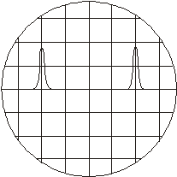
Calculate the time, in microseconds, between one peak of one ultrasound pulse and the peak of the next.
___________________________________________________________________
Time = _______________ microseconds
(1)
(e) Ultrasounds are partially reflected when they reach a boundary between two different media.
The time taken for the reflection from the boundary to reach the detector can be seen
from the screen.
What can be calculated from this time interval?
___________________________________________________________________
___________________________________________________________________
(2)
(f) Explain what action scientists should take if they find evidence that ultrasonic waves may be harmful to human health.
___________________________________________________________________
___________________________________________________________________
___________________________________________________________________
(2)
(Total 9 marks)
Q10.
(a) Explain what an ultrasound wave is.
___________________________________________________________________
___________________________________________________________________
___________________________________________________________________
___________________________________________________________________
(2)
(b) Ultrasound waves can be used to clean jewellery.
One method is to put the jewellery in a bath of cleaning fluid which contains an electronic oscillator. The electronic oscillator generates ultrasound waves in the cleaning fluid.
Suggest how these waves clean the jewellery.
___________________________________________________________________
___________________________________________________________________
___________________________________________________________________
___________________________________________________________________
(2)
(c) Ultrasound is used for pre-natal scanning. This is much safer than using X-rays. However, doctors were only sure it was safe after experiments on mice.
Explain whether or not you think that these experiments were justified.
___________________________________________________________________
___________________________________________________________________
___________________________________________________________________
___________________________________________________________________
(2)
(Total 6 marks)
Q11.
Bats use the reflection of high pitched sound waves to determine the position of objects.
The image below shows a bat and an insect flying in front of the bat.
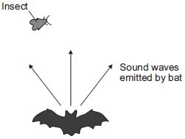
(a) What determines the pitch of a sound wave?
Tick (✔) one box.

Tick (✔)
amplitude
frequency
speed
(1)
(b) State the name given to reflected sound waves.
___________________________________________________________________
(1)
(c) The bat emits a sound wave with a frequency of 25.0 kHz and a wavelength of 0.0136 metres.
Calculate the speed of this sound wave.
___________________________________________________________________
___________________________________________________________________
___________________________________________________________________
Speed = ____________ m/s
(2)
(d) Sound waves are longitudinal. Describe a longitudinal sound wave.
___________________________________________________________________
___________________________________________________________________
___________________________________________________________________
___________________________________________________________________
(2)
(Total 6 marks)
Q12.
(a) The diagrams show oscilloscope traces for the same musical note played on two different instruments. The oscilloscope settings are not changed.
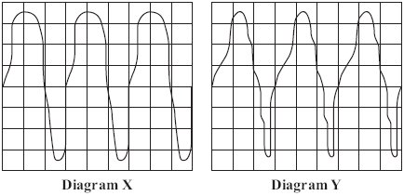
(i) How can you tell, from the diagrams, that it is the same musical note?
______________________________________________________________
______________________________________________________________
(1)
(ii) How can you tell, from the diagrams, that the musical note has been played on different instruments?
______________________________________________________________
______________________________________________________________
(1)
(b) This passage is from an electronics magazine.

Electronic systems can be used to produce ultrasound waves.
These waves have a higher frequency than the upper limit for hearing in humans.
Ultrasound waves are partially reflected when they meet a boundary between two different media.
(i) Approximately what is the highest frequency that humans can hear?
State the number and the unit.
______________________________________________________________
(1)
(ii) What does the word media mean when it is used in this passage?
______________________________________________________________
______________________________________________________________
(1)
(iii) What happens to the ultrasound which reaches the boundary between two different media and is not reflected?
______________________________________________________________
______________________________________________________________
______________________________________________________________
______________________________________________________________
(2)
(Total 6 marks)
Q13.
(a) The diagram shows a microphone being used to detect the output from a loudspeaker.
The oscilloscope trace shows the wave pattern produced by the loudspeaker.
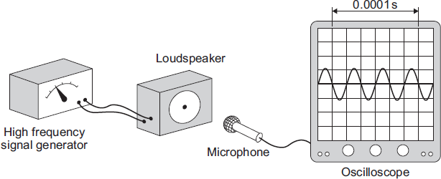
(i) How many waves are produced by the loudspeaker in 0.0001 seconds?
____________________
(1)
(ii) How many waves are produced by the loudspeaker every second?
Assume the input to the loudspeaker does not change.
______________________________________________________________
______________________________________________________________
(1)
(iii) A person with normal hearing cannot hear the sound produced by the loudspeaker.
Explain why.
______________________________________________________________
______________________________________________________________
______________________________________________________________
______________________________________________________________
(2)
(b) The diagram shows how a very high frequency sound wave can be used to check for internal cracks in a large steel bolt. The oscilloscope trace shows that the bolt does have an internal crack.
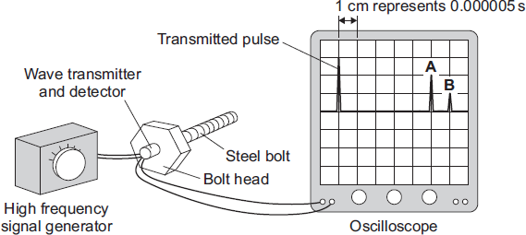
(i) Explain what happens to produce pulse A and pulse B.
______________________________________________________________
______________________________________________________________
______________________________________________________________
______________________________________________________________
(2)
(ii) Use the information in the diagram and the equation in the box to calculate the distance from the head of the bolt to the internal crack.

distance = speed × time
Speed of sound through steel = 6000 m/s
Show clearly how you work out your answer.
______________________________________________________________
______________________________________________________________
______________________________________________________________
______________________________________________________________
______________________________________________________________
______________________________________________________________
(3)
(Total 9 marks)

Mark schemes
Q1.
(a) C
1
(b) B
1
(c)

1
period = 0.0002 (s)
1
(d) any named electromagnetic wave
allow electromagnetic (wave)
1
(e) F
1
(f)
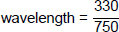
1
= 0.44 (m)
1
(g) Level 2: The method would lead to the production of a valid outcome. The key steps are identified and logically sequenced.
3−4
Level 1: The method would not lead to a valid outcome. Some relevant steps are identified, but links are not made clear.
1−2
No relevant content
0
Indicative content
method of making sound
eg cymbals, wooden blocks, starting pistol
measuring distance
• measuring distance between sound source and detector eg distance to wall, distance along track, distance between microphones
• use of measuring instrument eg tape measure, trundle wheel, metre rule
measuring time
• timing started when sound made and timing stopped when sound heard
• use of measuring instrument eg stopwatch, oscilloscope, data logger
extra detail
• dividing time by 2 or multiply distance by 2 for echo method
• use of equation speed =
(h) increases
1
[13]
Q2.
(a) the oscillation / vibration (causing the wave)
a movement causes the wave is insufficient
1
for a transverse wave is perpendicular to the direction of energy transfer
accept direction of wave travel
1
and for a longitudinal wave is parallel to the direction of energy transfer
accept direction of wave travel
if no marks awarded allow 1 mark for correctly linking perpendicular with transverse and parallel with longitudinal
the marks may be scored by the drawing of two correctly labelled diagrams
1
(b) for radio waves:
accept converse for each mark
are transverse
1
travel at speed of light / higher speed
1
have greater frequencies
1
can travel through vacuum
accept sound waves are not electromagnetic for 1 mark
1
[7]
Q3.
(a) transverse
1
(b) the water at point X moves up and down
1
(c) v = 2.0 × 0.032
1
v = 0.064 (m/s)
1
m/s
1
(d) energy
1
(e) D
1
(f) B
1
[8]
Q4.
(a) vibrates (owtte)
for one mark
1
(b) (i) higher
for one mark
1
(ii) louder
for one mark
1
(c) (i) ultrasonic (ultrasound)
for one mark
1
(ii) different frequency / wavelength / pitch
gains 1 mark
but
high frequency / pitch, higher frequency /pitch (lower frequency / pitch wrong)
gains 2 marks
2
[6]
Q5.
(a) wavelength = Q
1
(b) 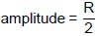
1
(c) radio waves
1
(d) s = 300 000 000 × 0.000009
1
s = 2700 (m)
1
(e) satellite communications
or
cooking /heating food
allow WiFi
1
[6]
Q6.
(a) (i) wavelength
accept frequency
accept speed
1
(ii) amplitude
accept energy
height is insufficient
1
(iii) sound
1
(b) 0.12
allow 1 mark for correct substitution, ie 8 × 0.015 provided no subsequent step shown
2
metre per second or m/s or metre/second
do not accept mps
units must be consistent with numerical answers
1
[6]
Q7.
(a) 20 000 Hz
1
(b) 400 (m)
allow 1 mark for correct
substitution ie 1600 × 0.25
provided no subsequent steps shown
an answer of 200 (m) gains 1 mark
2
(c) twice
1
(d) From pulse 1 to pulse 3 the distance (to the sea floor) decreased
accept the sea got shallower
or
the submarine went deeper for the distance decreased
1
then (after pulse 3) the distance (to the sea floor) increased
accept the sea got deeper
or
the submarine rose for the distance increased
An answer of the distance decreased then increased gains 1 mark
1
[6]
Q8.
(a) wavelength
1
frequency
1
this order only
(b) parallel
1
(c) 8000 Hz
1
(d) period = 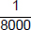
allow ecf from part (c)
1
0.000125 (s)
1
(e) 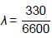
1
λ = 0.050
allow 0.05
1
m
1
(e) distance travelled = speed × time
or
s = vt
allow any correct rearrangement
1
(f) 13.2 = 330 × t
1
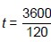
1
t = 0.040 (s)
allow 0.040 (s)
1
(g) loudspeaker B is closer to the technician (than speaker A)
‘it’ means speaker B
1
so the sound would take more time to travel (to the technician)
1
so the sound from each speaker arrives at the technician at the same time
1
[16]
Q9.
(a) 20000
accept any unambiguous indication
1
(b) kilohertz
credit misspellings
credit ‘1000 hertz’ or ‘1000 Hz’
accept 1000 oscillations/beats/waves per second
1
(c) (i) cleaning (e.g. something delicate such as a watch)
or quality control/flaw detection
credit any appropriate extra Specification response
e.g. sonar
1
(ii) pre-natal (scanning)
do not credit just ‘scanning’/medical scanning/ scanning a baby
credit any appropriate extra Specification response
e.g. destruction of (kidney) stones or cleaning teeth
1
(d) 8 (μs)
1
(e) distance (1)
between the boundary and the detector (1)
accept ‘between the boundary and the source’
accept any correct use of speed = distance/time
2
(f) examples
publish/tell doctors/the public (1) ... their evidence/results/research/data (1)
carry out more research/tests (1) ... to make sure/check reliability (1)
allow a wide variety of appropriate responses
valid point (1) appropriate example/qualification/expansion/etc. (1)
allow just ‘stop using them/ultrasonic waves’ (1)
allow using them (only) for industrial purposes (1)
2
[9]
Q10.
(a) sound / mechanical / longitudinal (wave )
1
any one from:
• above 20 000 hertz / 20kHz
• above (human) audible range
• cannot be heard by humans
1
(b) either
particles / molecules / fluid vibrate(s) (1)
(and) knock particles of dirt off the jewellery (1)
or
by the process of cavitation (1)
accept ‘formation and collapse of tiny bubbles’
which breaks up / releases dirt from the surface (1)
2
(c)either both pro
or both con
or one of each
either
two appropriate points gain 1 mark each
or
one appropriate point (and) appropriate qualification / amplification
examples
other mammals (sufficiently) similar to humans (1)
so results appropriate (1)
unethical to experiment on humans (1)
so it is better to experiment on mice (1)
knowledge / techniques will benefit humans (1)
and also other animals (1)
experiments were justified because ultrasound has proved useful (1)
2
[6]
Q11.
(a) frequency
1
(b) echo(es)
1
(c) 340 (m/s)
allow 1 mark for correct substitution ie 25 000 × 0.0136 provided no subsequent step
or
allow 1 mark for a correct calculation showing an incorrect value from conversion to hertz × 0.0136
an answer of 0.34 gains 1 mark
2
(d) (a wave where the) oscillations are parallel to the direction of energy transfer
both marking points may appear as labels on a diagram
accept vibrations for oscillations
accept in same direction as for parallel to
allow direction of wave (motion) for direction of energy transfer
allow 1 mark for a correct calculation showing an incorrect value from conversion to hertz × 0.0136
1
causing (areas of) compression and rarefaction
accept correct description in terms of particles
mechanical wave is insufficient
needs a medium to travel through is insufficient
1
[6]
Q12.
(a) (i) same frequency / period / pitch / wavelength
ignore references to amplitude
1
(ii) differences in waveform / shape / quality
accept the diagrams are not identical
1
(b) (i) 20 000 Hz / hertz
or 20 kHz / kilohertz
in both cases, if the symbol rather than the name is used, it must be correct in every detail
1
(ii) material(s) / substance(s) (through which sound travels)
1
(iii) is absorbed
accept (some) sound (energy) is transformed / transferred as heat / thermal energy
1
is transmitted
accept is refracted
accept changes speed
accept changes velocity
do not accept is diffracted
do not accept is diffused
do not accept is dissipated
1
[6]
Q13.
(a) (i) 3
1
(ii) 30 000 or 10 000 × their (a)(i) correctly calculated
1
(iii) any two from:
• frequency is above 20 000 (Hz)
accept the frequency is 30 000
• frequency is above the upper limit of audible range
• upper limit of audible range equals 20 000 (Hz)
ignore reference to lower limit
• it is ultrasound/ultrasonic
2
(b) (i) wave (partially) reflected
1
at crack to produce A and end of bolt to produce B
accept at both ends of the crack
1
(ii) 0.075 (m) allow 2 marks for time = 0.0000125
allow 1 mark for time = 0.000025
answers 0.15 or 0.015 or 0.09 gain 2 marks
answers 0.18 or 0.03 gain 1 mark
the unit is not required but if given must be consistent with numerical answer for the available marks
3
[9]

